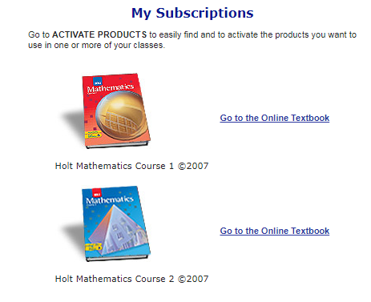Name _________________________________________________ Hour___________  
**Course 1 Online Textbook Preview**

1. **Log in with the following information:**

**Username: parcells1 Password: u8e7v**

1. **Click on “Go to the Online Textbook”.**
2. **Select “Chapter 1: Whole Numbers and Patterns” in the upper left-hand corner on the drop down menu.**
3. **Click on “Lesson 1-3: Exponents” from the drop down menu.**
4. **Click “GO”.**
5. 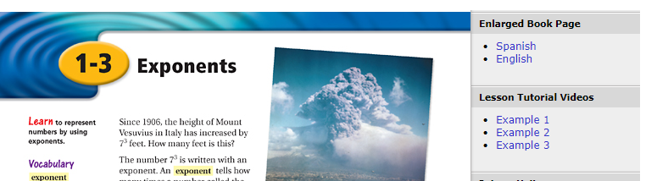**Watch any one of the videos and WRITE THE EXAMPLES YOU SEE BELOW. If you don’t have headphones, you can put on CC (English) to see the words as Professor Burger speaks.**
6. **Click on Example 1,2 or 3 under “Lesson Tutorial Videos” to watch the video.**

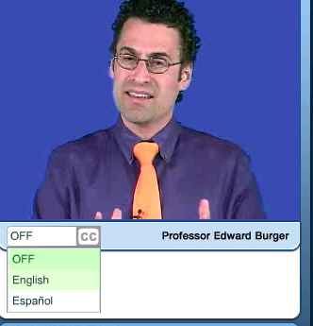**Write examples here**:

1. 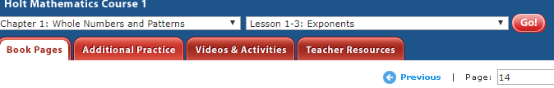**Click on the “Additional Practice” Tab.**
2. 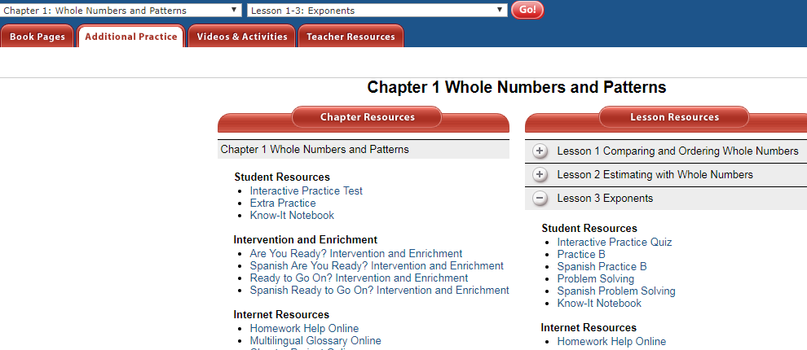**Click on “Lesson 3”.**
3. **Click on the “Interactive Quiz” and answers all the problems.   
   Write the quiz problems and answers here:**
4. **___________2. ____________ 3. ________________ 4. ________________5. _______________**
5. 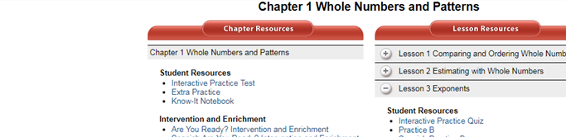**Click on “Interactive Practice Test”. Answer as many questions as you can.**

**Record your scores here.**

**Interactive Practice Quiz score: ______________ Interactive Practice Test score: _____________**

1. **Click on “Extra Practice’. Do the problems below.**



**Skip the first 16 problems. Start by answering #17 below.**

**17) _________________________________ 24) _________________________________**

**18) _________________________________ 25) _________________________________**

**19) _________________________________ 26) _________________________________**

**20) _________________________________ 27) _________________________________**

**21) _________________________________ 28) _________________________________**

**22) ________________________________ 29) _________________________________**

**23) _________________________________ 30) _________________________________**

**Turn over**

**Take some time to preview other parts of this website. List three other things that you learned that would be useful to you throughout the school year in math.**

1. **________________________________________________________________________________________________________________________________________________________________________**

**____________________________________________________________________________________**

1. **________________________________________________________________________________________________________________________________________________________________________**

**____________________________________________________________________________________**

1. **________________________________________________________________________________________________________________________________________________________________________**

**____________________________________________________________________________________**

**Name two things you like about the website.**

1. **________________________________________________________________________________________________________________________________________________________________________**

**____________________________________________________________________________________**

1. **________________________________________________________________________________________________________________________________________________________________________**